**Matkul : Pemrograman Perangkat Bergerak - TI – S1**

**NIM : A11.2019.11688**

**Nama : Bayu Prasetya Adji Sugiyarto**

**Pertemuan : 2**

**Intent two activities**

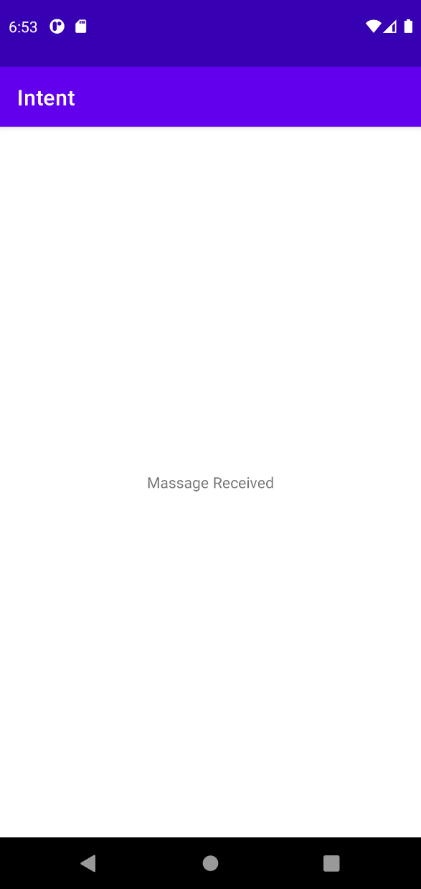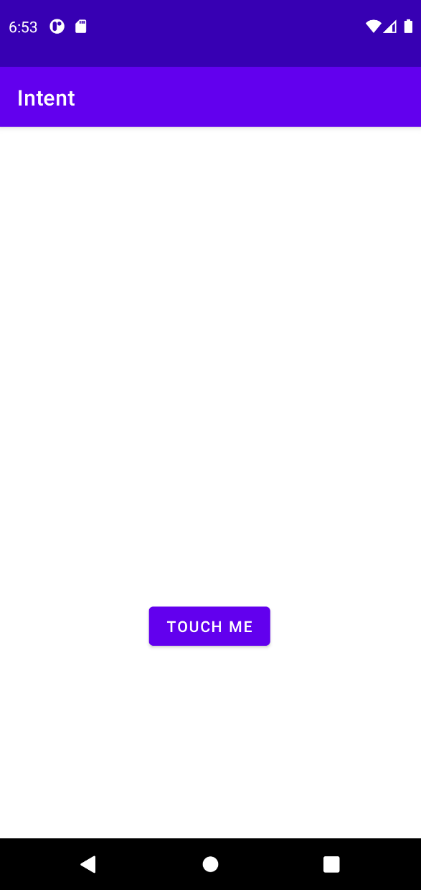

**Java** MainActivity

package com.example.intent;  
  
import androidx.appcompat.app.AppCompatActivity;  
  
import android.content.Intent;  
import android.os.Bundle;  
import android.view.View;  
import android.widget.Button;  
  
public class MainActivity extends AppCompatActivity {  
  
 @Override  
 protected void onCreate(Bundle savedInstanceState) {  
 super.onCreate(savedInstanceState);  
 setContentView(R.layout.*activity_main*);  
 }  
  
 public void openMainActivity2(View v){  
 Intent i = new Intent(this, MainActivity2.class);  
 startActivity(i);  
 }  
}

**Java** MainActivity2

package com.example.intent;  
  
import androidx.appcompat.app.AppCompatActivity;  
  
import android.os.Bundle;  
  
public class MainActivity2 extends AppCompatActivity {  
  
 @Override  
 protected void onCreate(Bundle savedInstanceState) {  
 super.onCreate(savedInstanceState);  
 setContentView(R.layout.*activity_main2*);  
 }  
}

**LAYOUT**

**Activity_main**

<RelativeLayout xmlns:android="http://schemas.android.com/apk/res/android"  
 xmlns:app="http://schemas.android.com/apk/res-auto"  
 xmlns:tools="http://schemas.android.com/tools"  
 android:layout_width="match_parent"  
 android:layout_height="match_parent"  
 tools:context=".MainActivity">  
  
 <Button  
 android:id="@+id/button"  
 android:layout_width="wrap_content"  
 android:layout_height="wrap_content"  
 android:layout_alignParentStart="true"  
 android:layout_alignParentTop="true"  
 android:layout_centerHorizontal="true"  
 android:layout_marginStart="139dp"  
 android:layout_marginTop="441dp"  
 android:text="Touch me"  
 android:onClick="openMainActivity2"/>  
</RelativeLayout>

**Activity_main2**

<?xml version="1.0" encoding="utf-8"?>  
<RelativeLayout xmlns:android="http://schemas.android.com/apk/res/android"  
 xmlns:app="http://schemas.android.com/apk/res-auto"  
 xmlns:tools="http://schemas.android.com/tools"  
 android:layout_width="match_parent"  
 android:layout_height="match_parent"  
 tools:context=".MainActivity2">  
  
 <TextView  
 android:layout_width="wrap_content"  
 android:layout_height="wrap_content"  
 android:layout_centerInParent="true"  
 android:text="Massage Received" />  
  
</RelativeLayout>

**Implicit App**

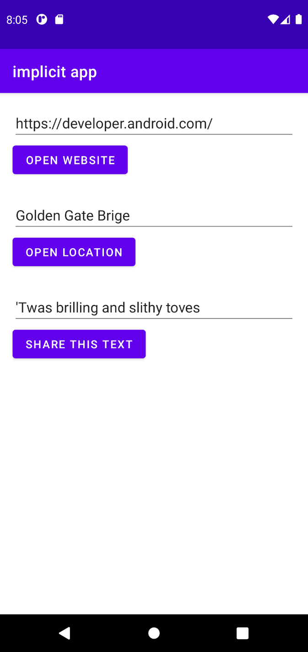

**String.xml**

<resources>  
 <string name="edittext_url">https://developer.android.com/</string>  
 <string name="button_url">Open website</string>  
 <string name="app_name">implicit app</string>  
 <string name="edittext_loc">Golden Gate Brige</string>  
 <string name="button_loc">Open Location</string>  
 <string name="edittext_share">\'Twas brilling and slithy toves</string>  
 <string name="button_share">Share this text</string>  
</resources>

**MainActivity.java**

package com.example.implicitapp;  
  
import androidx.appcompat.app.AppCompatActivity;  
import androidx.core.app.ShareCompat;  
  
import android.content.Intent;  
import android.net.Uri;  
import android.net.UrlQuerySanitizer;  
import android.nfc.Tag;  
import android.os.Bundle;  
import android.os.strictmode.ImplicitDirectBootViolation;  
import android.util.Log;  
import android.view.View;  
import android.widget.EditText;  
  
import java.net.URL;  
  
public class MainActivity extends AppCompatActivity {  
  
 private EditText WebEdittxt;  
 private EditText Located;  
 private EditText shareedit;  
  
 @Override  
 protected void onCreate(Bundle savedInstanceState) {  
 super.onCreate(savedInstanceState);  
 setContentView(R.layout.*activity_main*);  
  
 WebEdittxt = findViewById(R.id.*link*);  
 Located = findViewById(R.id.*location*);  
 shareedit = findViewById(R.id.*share*);  
 }  
  
 public void openWebsite(View view) {  
 String url = WebEdittxt.getText().toString();  
  
 Uri webpage = Uri.*parse*(url);  
  
 Intent intent = new Intent(Intent.*ACTION_VIEW*, webpage);  
  
 if (intent.resolveActivity(getPackageManager()) != null){  
 startActivity(intent);  
 } else{  
 Log.*d*("ImplicitIntents", "Cant Handle This");  
 }  
 }  
  
 public void openLocation(View view) {  
 String Loc = Located.getText().toString();  
  
 Uri address = Uri.*parse*("geo:0.0?q" + Loc);  
  
 Intent intent = new Intent(Intent.*ACTION_VIEW*, address);  
  
 if (intent.resolveActivity(getPackageManager()) != null){  
 startActivity(intent);  
 } else{  
 Log.*d*("ImplicitIntents", "Cant Handle This");  
 }  
 }  
  
 public void sharethistext(View view) {  
 String txt = shareedit.getText().toString();  
  
 String mimetype = "text/plain";  
 ShareCompat.IntentBuilder  
 .*from*(this)  
 .setType(mimetype)  
 .setChooserTitle("Share this Text with : ")  
 .setText(txt)  
 .startChooser();  
  
 }  
}

**LAYOUT**

**activity_main.xml**

<?xml version="1.0" encoding="utf-8"?>  
<LinearLayout xmlns:android="http://schemas.android.com/apk/res/android"  
 xmlns:app="http://schemas.android.com/apk/res-auto"  
 xmlns:tools="http://schemas.android.com/tools"  
 android:layout_width="match_parent"  
 android:layout_height="match_parent"  
 android:orientation="vertical"  
 android:padding="16dp"  
 tools:context=".MainActivity">  
  
 <EditText  
 android:id="@+id/link"  
 android:layout_width="match_parent"  
 android:layout_height="wrap_content"  
 android:text="@string/edittext_url" />  
  
 <Button  
 android:id="@+id/btnlink"  
 android:layout_width="wrap_content"  
 android:layout_height="wrap_content"  
 android:text="@string/button_url"  
 android:layout_marginBottom="24dp"  
 android:onClick="openWebsite" />  
  
 <EditText  
 android:id="@+id/location"  
 android:layout_width="match_parent"  
 android:layout_height="wrap_content"  
 android:text="@string/edittext_loc" />  
  
 <Button  
 android:id="@+id/btnloc"  
 android:layout_width="wrap_content"  
 android:layout_height="wrap_content"  
 android:text="@string/button_loc"  
 android:layout_marginBottom="24dp"  
 android:onClick="openLocation" />  
  
 <EditText  
 android:id="@+id/share"  
 android:layout_width="match_parent"  
 android:layout_height="wrap_content"  
 android:text="@string/edittext_share" />  
  
 <Button  
 android:id="@+id/btnshare"  
 android:layout_width="wrap_content"  
 android:layout_height="wrap_content"  
 android:text="@string/button_share"  
 android:layout_marginBottom="24dp"  
 android:onClick="sharethistext" />  
</LinearLayout>

**Life Cycle Two Activities**

**MainActivity.java**

package com.example.lifecycle;  
  
import androidx.appcompat.app.AppCompatActivity;  
  
import android.content.Intent;  
import android.nfc.Tag;  
import android.os.Bundle;  
import android.util.Log;  
import android.view.View;  
  
public class MainActivity extends AppCompatActivity {  
  
 private static final String *TAG* = "MainActivity";  
  
 @Override  
 protected void onCreate(Bundle savedInstanceState) {  
 super.onCreate(savedInstanceState);  
 setContentView(R.layout.*activity_main*);  
  
 Log.*i*(*TAG*, "onCreate");  
 }  
  
 @Override  
 protected void onStart(){  
 super.onStart();  
  
 Log.*i*(*TAG*, "onStart");  
 }  
  
 @Override  
 protected void onResume(){  
 super.onResume();  
  
 Log.*i*(*TAG*, "onResume");  
 }  
  
 @Override  
 protected void onPause(){  
 super.onPause();  
  
 Log.*i*(*TAG*, "onPause");  
 }  
  
 @Override  
 protected void onStop(){  
 super.onStop();  
  
 Log.*i*(*TAG*, "onStop");  
 }  
  
 @Override  
 protected void onDestroy(){  
 super.onDestroy();  
  
 Log.*i*(*TAG*, "onDestroy");  
 }  
  
 @Override  
 protected void onRestart(){  
 super.onRestart();  
  
 Log.*i*(*TAG*, "onRestart");  
 }  
  
 public void openActivity2(View v){  
 Intent i = new Intent(this, MainActivity2.class);  
 startActivity(i);  
 }  
}

**Mainactivity2.java**

package com.example.lifecycle;  
  
import androidx.appcompat.app.AppCompatActivity;  
  
import android.os.Bundle;  
  
public class MainActivity2 extends AppCompatActivity {  
  
 @Override  
 protected void onCreate(Bundle savedInstanceState) {  
 super.onCreate(savedInstanceState);  
 setContentView(R.layout.*activity_main2*);  
 }  
}

**LAYOUT**

**Activity_main.xml**

<?xml version="1.0" encoding="utf-8"?>  
<RelativeLayout xmlns:android="http://schemas.android.com/apk/res/android"  
 xmlns:app="http://schemas.android.com/apk/res-auto"  
 xmlns:tools="http://schemas.android.com/tools"  
 android:layout_width="match_parent"  
 android:layout_height="match_parent"  
 tools:context=".MainActivity">  
  
 <Button  
 android:layout_width="wrap_content"  
 android:layout_height="wrap_content"  
 android:layout_centerInParent="true"  
 android:text="Open Activity 2"  
 android:onClick="openActivity2"/>  
  
</RelativeLayout>

**Activity_main2.xml**

<?xml version="1.0" encoding="utf-8"?>  
<RelativeLayout xmlns:android="http://schemas.android.com/apk/res/android"  
 xmlns:app="http://schemas.android.com/apk/res-auto"  
 xmlns:tools="http://schemas.android.com/tools"  
 android:layout_width="match_parent"  
 android:layout_height="match_parent"  
 tools:context=".MainActivity2">  
  
</RelativeLayout>

**CV/Biodata**

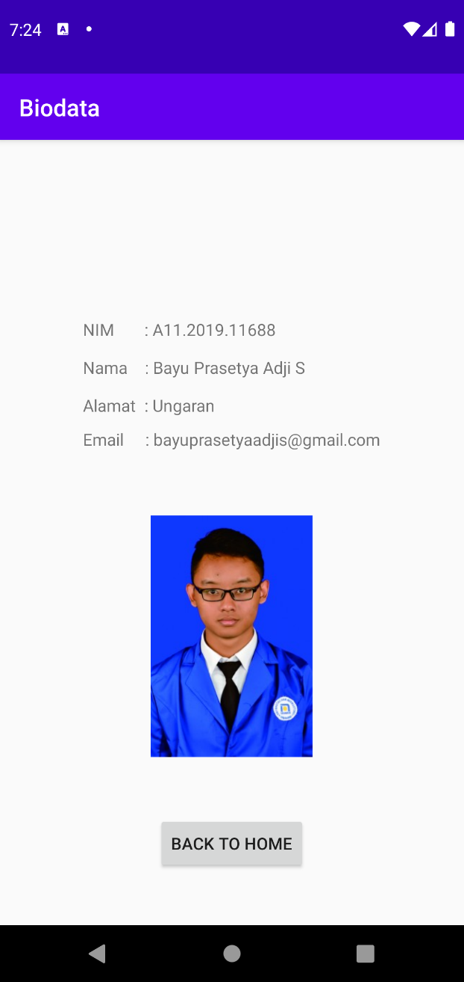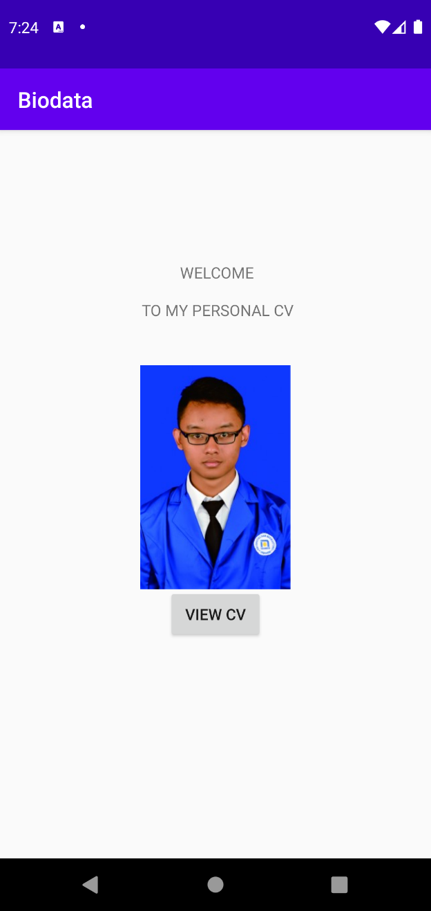

**Mainactivity.java**

package com.example.biodata;  
  
import android.content.Intent;  
import android.support.v7.app.AppCompatActivity;  
import android.os.Bundle;  
import android.util.Log;  
import android.view.View;  
import android.widget.Button;  
  
public class MainActivity extends AppCompatActivity {  
 private static final String *TAG* = "MainActivity";  
  
 @Override  
 protected void onCreate(Bundle savedInstanceState) {  
 super.onCreate(savedInstanceState);  
 setContentView(R.layout.*activity_main*);  
  
 Log.*i*(*TAG*, "onCreate");  
 }  
  
 @Override  
 protected void onStart(){  
 super.onStart();  
  
 Log.*i*(*TAG*, "onStart");  
 }  
  
 @Override  
 protected void onResume(){  
 super.onResume();  
  
 Log.*i*(*TAG*, "onResume");  
 }  
  
 @Override  
 protected void onPause(){  
 super.onPause();  
  
 Log.*i*(*TAG*, "onPause");  
 }  
  
 @Override  
 protected void onStop(){  
 super.onStop();  
  
 Log.*i*(*TAG*, "onStop");  
 }  
  
 @Override  
 protected void onDestroy(){  
 super.onDestroy();  
  
 Log.*i*(*TAG*, "onDestroy");  
 }  
  
 @Override  
 protected void onRestart(){  
 super.onRestart();  
  
 Log.*i*(*TAG*, "onRestart");  
 }  
  
 public void openActivity2(View v){  
 Intent i = new Intent(this, MainActivity2.class);  
 startActivity(i);  
 }  
}

**Mainactivity2.java**

package com.example.biodata;  
  
import android.content.Intent;  
import android.support.v7.app.AppCompatActivity;  
import android.os.Bundle;  
import android.view.View;  
import android.widget.Button;  
  
public class MainActivity2 extends AppCompatActivity {  
  
 @Override  
 protected void onCreate(Bundle savedInstanceState) {  
 super.onCreate(savedInstanceState);  
 setContentView(R.layout.*activity_main2*);  
  
 }  
  
 public void openActivity(View v){  
 Intent i = new Intent(this, MainActivity.class);  
 startActivity(i);  
 }  
}

**LAYOUT**

**Activity_main.xml**

<?xml version="1.0" encoding="utf-8"?>  
<RelativeLayout xmlns:android="http://schemas.android.com/apk/res/android"  
 xmlns:app="http://schemas.android.com/apk/res-auto"  
 xmlns:tools="http://schemas.android.com/tools"  
 android:layout_width="match_parent"  
 android:layout_height="match_parent"  
 tools:context=".MainActivity"  
 >  
  
 <TextView  
 android:layout_width="wrap_content"  
 android:layout_height="wrap_content"  
 android:layout_alignParentStart="true"  
 android:layout_alignParentTop="true"  
 android:layout_centerHorizontal="true"  
 android:layout_marginStart="164dp"  
 android:layout_marginTop="120dp"  
 android:text="WELCOME" />  
  
 <TextView  
 android:layout_width="wrap_content"  
 android:layout_height="wrap_content"  
 android:layout_alignParentStart="true"  
 android:layout_alignParentTop="true"  
 android:layout_centerHorizontal="true"  
 android:layout_marginStart="129dp"  
 android:layout_marginTop="154dp"  
 android:text="TO MY PERSONAL CV" />  
  
 <Button  
 android:id="@+id/button1"  
 android:layout_width="wrap_content"  
 android:layout_height="wrap_content"  
 android:layout_alignParentBottom="true"  
 android:layout_centerHorizontal="true"  
 android:layout_marginBottom="197dp"  
 android:text="VIEW CV"  
 android:onClick="openActivity2"/>  
  
 <ImageView  
 android:id="@+id/imageView2"  
 android:layout_width="137dp"  
 android:layout_height="212dp"  
 android:layout_alignParentTop="true"  
 android:layout_centerHorizontal="true"  
 android:layout_marginTop="210dp"  
 app:srcCompat="@drawable/a11_2019_11688" />  
  
  
</RelativeLayout>

**Activity_main2.xml**

<?xml version="1.0" encoding="utf-8"?>  
<RelativeLayout xmlns:android="http://schemas.android.com/apk/res/android"  
 xmlns:app="http://schemas.android.com/apk/res-auto"  
 xmlns:tools="http://schemas.android.com/tools"  
 android:layout_width="match_parent"  
 android:layout_height="match_parent"  
 tools:context=".MainActivity2">  
  
 <TextView  
 android:layout_width="wrap_content"  
 android:layout_height="wrap_content"  
 android:layout_alignParentStart="true"  
 android:layout_alignParentTop="true"  
 android:layout_centerVertical="true"  
 android:layout_marginStart="70dp"  
 android:layout_marginTop="150dp"  
 android:text="NIM : A11.2019.11688" />  
  
 <TextView  
 android:layout_width="wrap_content"  
 android:layout_height="wrap_content"  
 android:layout_alignParentStart="true"  
 android:layout_alignParentTop="true"  
 android:layout_centerVertical="true"  
 android:layout_marginStart="70dp"  
 android:layout_marginTop="182dp"  
 android:text="Nama : Bayu Prasetya Adji S" />  
  
 <TextView  
 android:layout_width="wrap_content"  
 android:layout_height="wrap_content"  
 android:layout_alignParentStart="true"  
 android:layout_alignParentTop="true"  
 android:layout_centerVertical="true"  
 android:layout_marginStart="70dp"  
 android:layout_marginTop="214dp"  
 android:text="Alamat : Ungaran" />  
  
 <TextView  
 android:layout_width="wrap_content"  
 android:layout_height="wrap_content"  
 android:layout_alignParentStart="true"  
 android:layout_alignParentTop="true"  
 android:layout_centerInParent="true"  
 android:layout_marginStart="70dp"  
 android:layout_marginTop="243dp"  
 android:text="Email : bayuprasetyaadjis@gmail.com"/>  
  
 <ImageView  
 android:id="@+id/imageView2"  
 android:layout_width="137dp"  
 android:layout_height="212dp"  
 android:layout_alignParentTop="true"  
 android:layout_centerInParent="true"  
 android:layout_marginTop="313dp"  
 app:srcCompat="@drawable/a11_2019_11688" />  
  
 <Button  
 android:id="@+id/back"  
 android:layout_width="wrap_content"  
 android:layout_height="wrap_content"  
 android:layout_alignParentBottom="true"  
 android:layout_centerHorizontal="true"  
 android:layout_marginBottom="45dp"  
 android:onClick="openActivity"  
 android:text="BACK TO HOME" />  
</RelativeLayout>